Laboratory Activity No. 2

**Group**

**Rowy, Chedrick F. (Leader)**

**Tolones, Sergej Jr. R.**

**Dela Cruz, Allyson**

**Baradi, Venice P.**

**Nebrida, Jhon Marlon C.**

**1. Screenshot of an empty form.**

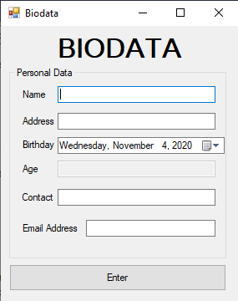

**2. Screenshot of accomplished form.**

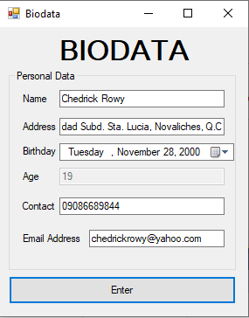

**3. Screenshot of the Message Box containing all the details that the user has entered in the form.**

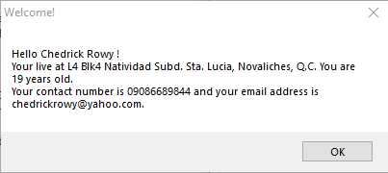

**4. Leader's Report.**

**Rowy, Chedrick F. (Leader) - Participated**

**Tolones, Sergej Jr. R. - Participated**

**Dela Cruz, Allyson – Participated**

**Baradi, Venice P. - Participated**

**Nebrida, Jhon Marlon C. – Participated**

**5. Screenshot of Google Meet Meeting.**

